CMPT 310 Assignment 2

Junchen Li

301385486

2021/2/27

**Question 1:**

1. An agent that senses only partial information about the state cannot be perfectly rational.

Answer: This is a false statement. From the definition, the ideal rational agent can choose an action which max its performance for given sequence and knowledge about the world. An agent that only senses partial information but can do above action could be rational. Counter ex: vacuum world is a rational but its sensors cannot know the state of next room.

1. There exist task environments in which no pure reflex agent can behave rationally.

Answer: This is a true statement. Any agent that is reflective will conflict with a task that requires memory, so there is a working environment that does not have a purely reflective agent -- one that completely requires memory of previous turns.

1. There exists a task environment in which every agent is rational.

Answer: This is a true statement. If there is a task environment in which any action (or no action) taken by all agents will give the same result, then every agent in that environment is rational

1. Every agent function is implementable by some program/machine combination.

Answer: This is a false statement. This is a very extreme statement, any so-called agent is an abstract existence, the implementation of the specific agent or through mechanical programs to achieve. Some proxies that theoretically exist may fail due to hardware problems (insufficient memory, overloaded system, no sensors).

1. Suppose an agent selects its action uniformly at random from the set of possible actions. There exists a deterministic task environment in which this agent is rational.

Answer: This is a true statement. The agent in the task environment can be determined to be rational if it can be determined that the different actions chosen by the agent each time will bring the same consequences or results

1. It is possible for a given agent to be perfectly rational in two distinct task environments.

Answer: This is a true statement. Suppose that two different task environments each have a condition that can be constrained. If you flip a coin, for example, if you have a situation where the coin is a fair coin, each side has a 50% chance. The other scenario is 20% more likely to be positive. This is rational for the agent to choose the positive case.

1. Every agent is rational in an unobservable environment.

Answer: This is a false statement. If an agent in an environment is not doing what it is supposed to do, it can be considered unreasonable. Like a vacuum robot that never moves or a vacuum robot that only moves but never suck. So not every agent in an unobservable environment is reasonable.

1. A perfectly rational poker-playing agent never loses.

Answer: This is a false statement. An agent proficient in all kinds of algorithms is very likely to be undefeated when playing against a human, but if you put two perfectly rational poker agents together, one of them will always lose. Because there is a random factor in poker which is the suit of the card that is drawn. So we can’t have a never lose perfectly rational poker-playing agent.

|  |  |  |  |  |  |  |
| --- | --- | --- | --- | --- | --- | --- |
|  | **A** | **B** | **C** | **E** | **G** | **L** |
| Result | 9 | 9 | 6 | 17 | 13 | 1 |

**Question 2:**

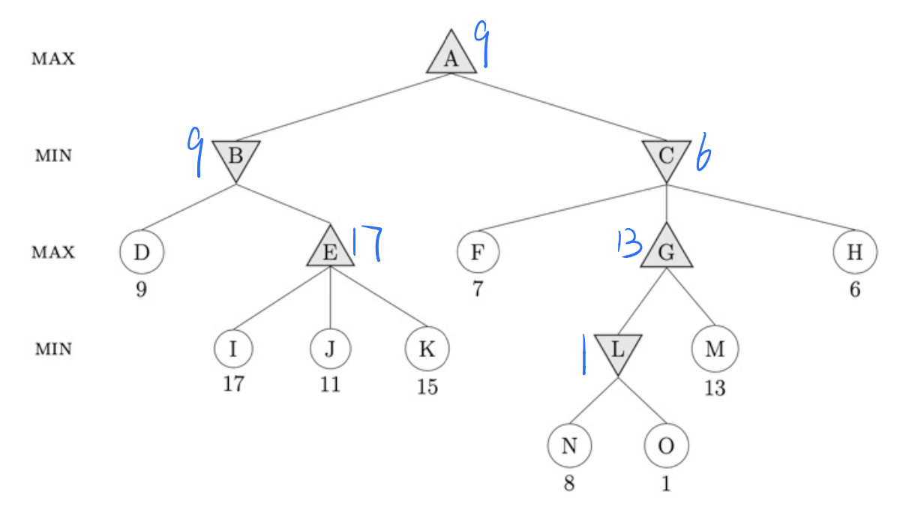

1. Left-to-right alpha-beta pruning

|  |  |  |  |  |  |  |
| --- | --- | --- | --- | --- | --- | --- |
|  | **A** | **B** | **C** | **E** | **G** | **L** |
|  | 9 |  | 9 | 17 | / | / |
|  |  | 9 | 7 | 9 | / | / |

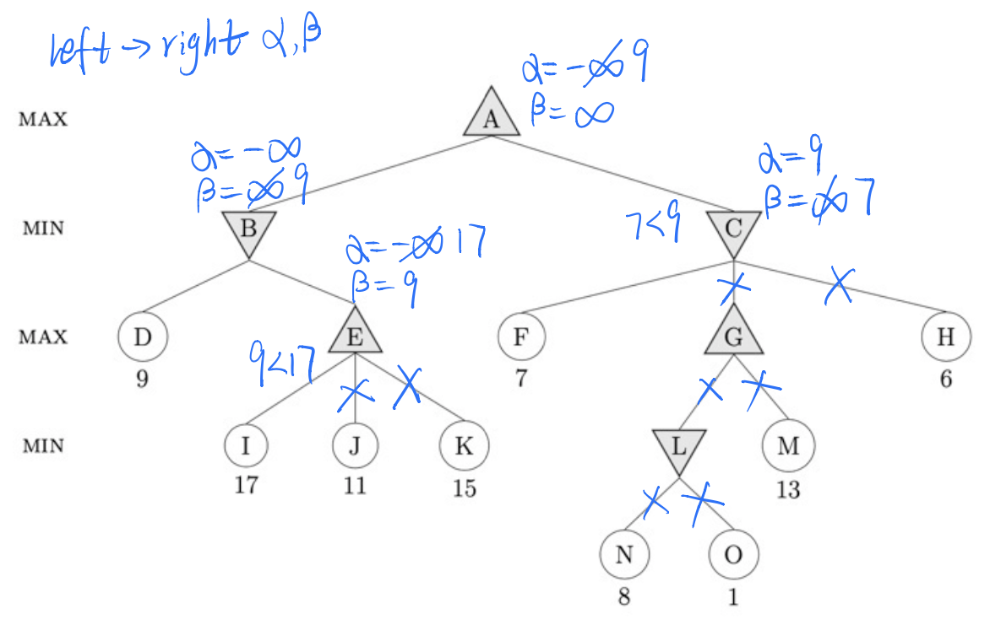G, L are nodes are not examined. J, K, N, O, M, H are leaves not examined

1. Right-to-left alpha-beta pruning

|  |  |  |  |  |  |  |
| --- | --- | --- | --- | --- | --- | --- |
|  | **A** | **B** | **C** | **E** | **G** | **L** |
|  | 9 | 6 |  | 17 | 13 | / |
|  |  | 9 | 6 |  | 6 | / |

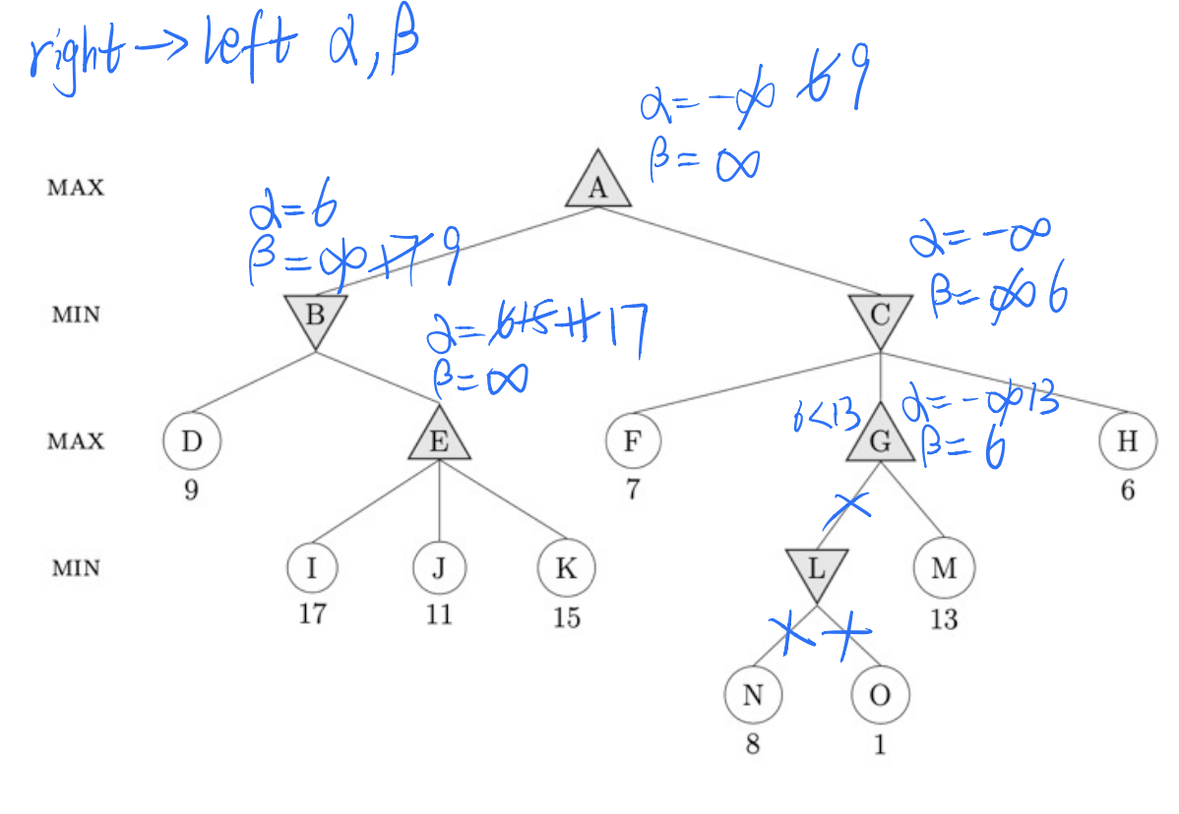Node L is not examined and N, O are leaves not examined.

**Question 3:**

a)

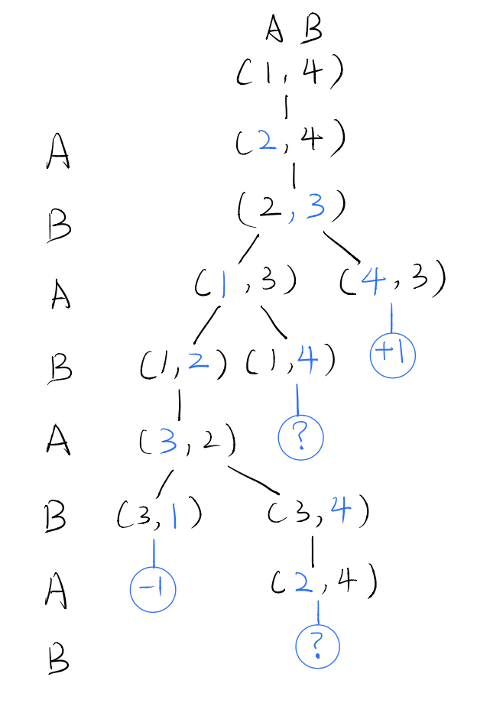There are two values in each pair brackets. The first one is correspond to the position of A and the second one is corresponding to the position of B.

b) I started from the bottom question mark circle. Whatever the choice it did below that question mark, the final result will do the MIN operation. So I guess the result will get and also for (2,4) and (3,4). The (3,1) I will get -1 as the result because of the player B already in the position 1 and we did MAX operation in (3,2). At most I will have at (3,2) and (1,2). Below the (1,4) I have other question mark, whatever the choice it did, the final result will do the MAX operation. So I guess the result will get and for (1,4) I have the same result. In the position (1,3) we did MAX operation, one is the and other is , so I can at most get +1 in the (1,3). For the (4,3), I also can get +1 because of player A already in the position 4. In the end we did MIN and MAX operation for both +1 and the final result we get is +1. The follow picture will show what I said.

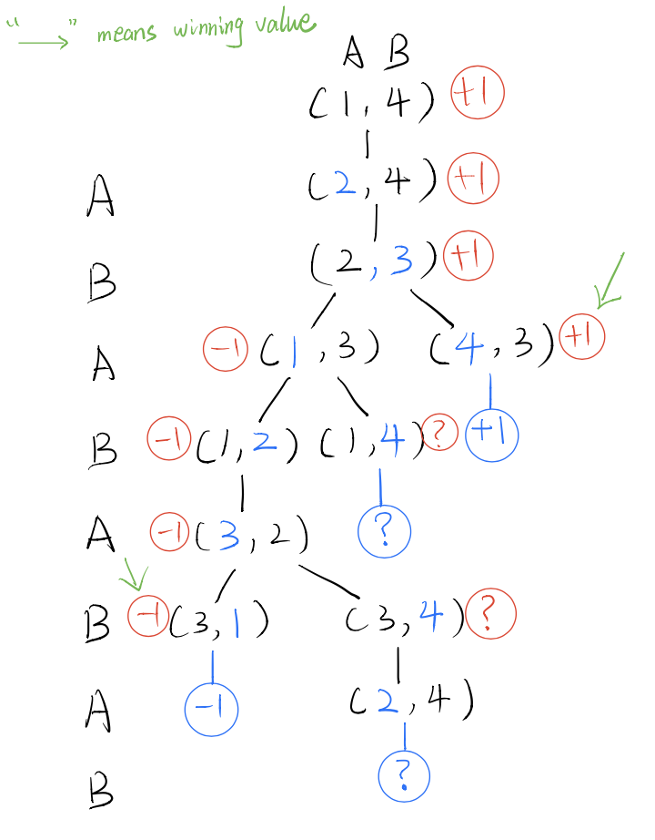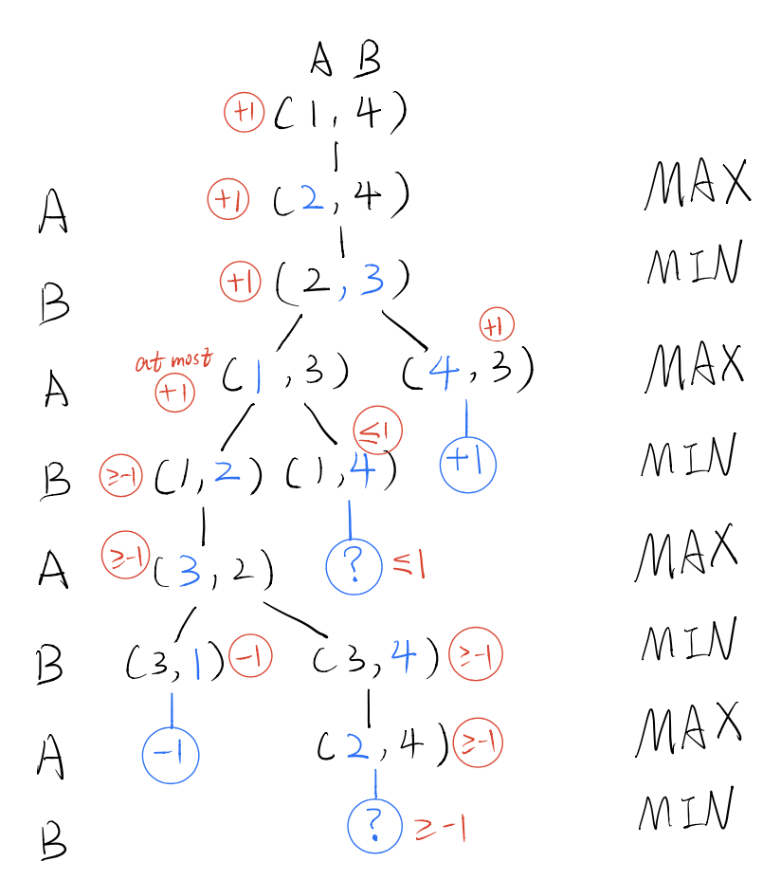(continue with part c question) Also, we can handle question mark in second way. The question values are handled by assuming that choosing between exist winning value and question value are always the winning game value. Like if MIN(-1, “ ? ”) and -1 is winning value so the result is -1 Notice that for all successors are question mark value, the back-up value are question mark value as well. The follow picture will show that situation.

c) Traditional minimax methods do not perform well in this problem. Because the traditional method runs Depth-first, there is no infinite loop situation. I modified the second more stable version according to part B method, please see B's second method. (Because the first method involves too many hypothetical guessing steps). The method doesn't work perfectly because these unpredictable situations give us some different answers. It is not clear how to handle these situations. So for all problems that involve infinite loops, we can treat this situation as if there is no result or even these unpredictable situations can give us a tie situation

d) For this example, when player moves his token first in each game, that player will has a winning strategy. Due to the rules say each turn must move to adjacent space. If we start with Player A then first round (2,3), second round A can directly go to the number 4 position and win this game. The same thing as the n square game. Even we think the n bigger than 2 and if there are no newer restrictions. Whatever the first player moves, his token will closer to the goal position. (Horizontally or vertically). And second player will chase the process and it always slower one move than other player. Even if second player wants to contain the first one or linger in original position, first token can go over it anyway. In conclusion, the first player to move will have a winning strategy.

**Question 4:**

1. Emily is a surgeon or a lawyer.

Answer:

1. Joe is an actor, but he also holds another job.

Answer:

1. All surgeons are doctors.

Answer:

1. Joe does not have a lawyer (i.e., is not a customer of any lawyer).

Answer:

1. Emily has a boss who is a lawyer.

Answer:

1. There exists a lawyer all of whose customers are doctors.

Answer:

1. Every surgeon has a lawyer.

Answer: